**PROCESS EQUIPMENT AND DESIGN DRAWING**

**PROJECT**

**IMPORTANCE AND TYPE OF SAFETY DEVICES ON PROCESS EQUIPMENTS**

**GROUP MEMBERS:**

**MAITREYA BABAR 13CHE1074**

**ROHAN WAGHELA 13CHE1075**

**DIGVIJAY BAGUL 13CHE1076**

**CHINMAY PATIL 12CHE1059**

**KIRAN SABALE 12CHE1068**

**INDEX**

**1. INTRODUCTION**

**2. HAZARDS**

**3.IMPORTANCE OF PRESSURERELIEF SYSTEM**

**4. SAFETY MEASURES IN EQUIPMENT DESIGN**

**4.1 About material of construction**

**4.2 Precautions in design and construction**

**4.3 Pressure vessels**

**4.4 Heat transfer equipments**

**4.5 Equipment involving electrical energy**

**4.6 Equipment involving rotary motion**

**4.7 Pressure relief devices**

**5. PARTS OF SAFETY RELIEF VALVE**

**6. DIMENSIONAL CHARACTERITICS OF SAFETY VALVES**

**7. OPERATIONAL CHARACTERISTICS OF SAFETY VALVES**

**8.ADVANTAGES AND DISADVANTAGES**

**9.CODES AND STANDARDS**

**10.CONCLUSION**

**11.REFERENCES**

**1. INTRODUCTION**

The chemical industry is more diverse than virtually any other process industry. Its products are omnipresent. Chemicals play a major role in manufacturing, essential to the entire range of industries such as pharmaceuticals, automobiles, textiles, paper and paint, agriculture, electronics, appliances and services. It is difficult at the same time to fully specify the uses of chemical products and processes. A world without the chemical industry would lack modern medicine, communications, and consumer products. The modern technology in developing these tailor made chemicals has been quite successful. However, the process and manufacturing facilities are challenged to maintain their edge in a highly competitive culture while facing continual scrutiny from the public and government to improve the safety of processes involving hazardous materials. The continuous burden of increasing the production of flammable organics, the competition to bring new products from laboratory scale to full scale production, the problem of familiarization with a stream of new technology have all extended the probabilities of hazards. The major hazards encountered in the operation of the plant in the chemical industries are toxic and corrosive chemicals release, fires, explosions, falls and faulty mechanized equipments. In many instances, more than one of these hazards occur either simultaneously or in tandem of each other. For example, a fire may lead to explosion which subsequently causes more fire and toxic release. Therefore, the design engineer must be aware of these hazards and must make every attempt to present a design which needs to be protective of the environment and of human health. Environmental issues must be considered not only within the context of chemical production but also during other stages of a chemical’s life cycle, such as transportation, use by customers, recycling activities, and ultimate disposal.Safety is the most important factor in designing a process system. Some undesiredconditions might happen leading to damage in a system. Control systems might beinstalled to prevent such conditions, but a second safety device is also needed. One kind ofsafety device which is commonly used in the processing industry is the relief valve. A reliefvalve is a type of valve to control or limit the pressure in a system by allowing thepressurized fluid to flow out from the system. The pressure in a system can build up by a process upset, instrument or equipment failure,or fire. When considering safety factors to minimizing the damage in industrial plant, it isimportant to properly select the pressure reliefvalve to be utilized. This design guidelinecovers the sizing and selection methods of pressure relief valves used in the typical process industries.

**2.HAZARDS**

An initial process hazard analysis must be made of the probable sources of hazards and it is performed on the processes, appropriate to the complexity to identify, evaluate and control the hazard. Take corrective measures to improve the safety of the process and plan actions that would be necessary if safety controls failed. Process hazard analysis is required for any process involving a highly hazardous chemical as identified in the standard. A process includes any manufacturing or use of a highly hazardous chemical, including storage, handling or movement of the chemical. Most simplified, any facility that has a designated hazardous chemical on-site in the quantities named in the standard must conduct a process hazard analysis for the equipment and process in which the material is used. The entire approach can be summarized as follows:

1. Identify the hazards: “what can possibly go wrong”

2. Evaluate the hazards: “what are all the causes and how bad it can be”

3. Control the hazards: “what should be done about it”

The sources of the hazard can be divided into two categories, namely, material hazards and process hazards.

**3. IMPORTANCE OF RELIEF SYSTEM**

In the daily operation of chemical processing plant, overpressure may happen due toincidents like inadvertent blocked discharge, fire exposure, tube rupture, check valvefailure, thermal expansion at a heat exchanger, and utility failures. This may lead to majorincident in a plant if the pressure relief system is not in place or not functional.Is very important to properly select the size and the location and to maintain the pressurerelief system to prevent or minimize the losses from major incident like a fire. The pressurerelief system is used to protect piping and equipment against excessive over-pressure andinsure personnel safety. Pressure relief systems consist of the pressure relief device, theflare piping system, flare separation drum and flare system. A pressure relief device isdesigned to open and relieve the excess pressure and then it recloses after normalconditions have been restored to prevent the further flow of fluid.

**4. SAFETY MEASURES IN EQUIPMENT DESIGN**

Till now we have discussed about number of safety measures for preventing or controlling hazards. Some of these measures are significant in equipment design problems. Here main focus is on considering equipment such as pressure vessels (i.e. reactors, heat exchangers etc.) and the equipment which involves rotary motion (example filters, agitators etc.). During the design stages of these items of equipment some important safety measures need to be considered are discussed in the following sections.

**4.1 About material of construction**

The selection of materials certainly involves a compromise between factors such as strength, corrosion resistance, elasticity, toughness, wear, fatigue resistance and ease of fabrication, as well as availability and cost. In some cases process conditions vary a good deal, which makes the choice of material difficult. The choice of the material is largely based on experience and even small variations in the constituents of the fluid streams make considerable difference to the material to be used. At the design stage, all reasonable hazards should be identified and listed, and a limit set for each variable which can lead to such a hazard. For instance, the consequences of material failure or deterioration should be considered, with limits for wear or corrosion being established. To ensure safe operation a critical analysis of the process conditions and material handled must be made.

**4.2 Precautions in design and construction**

It is generally known that preventing the effects of industrial accidents/hazards necessitates, above all, a high safety standard of potentially dangerous plants. These will vary according to the type of equipment. A properly designed piece of equipment will have in-built safety and loss prevention features. To prevent such failures the ideas and experience which are already available at various points in connection with emergency measures should be incorporated. reliability and flexibility, ease of operations, provision for future expansion, inspection and maintenance, emergency shutdown facility, standardization of equipment for rapid replacement, design to withstand probable pressure and temperature range, with facility to over pressure/temperature control etc. But at the same time it is not possible to give the list of precautions for each and individual unit operations, some are specified below

**4.3 pressure vessels**

For design and construction of pressure vessel and storage tanks Indian standards codes should be followed and vessels should be tested at 1.3 times the design pressure (Mahajani and Umarji, 2009). The design should be made to keep the vessels as simple as possible and it should not be overloaded with supplementary equipments. Thick weld joints made on the vessel should be given special attentions. The fatigue strength should be regularly monitored particularly if the vessel is exposed to pressure cycling, system changes, vibrations or similar factors which are likely to create fatigue conditions. Important point need to consider is that flange joints must be leak proof. All pressure vessels should be provided with pressure relief devices.

**4.4 Heat transfer equipments**

The heat transfer equipment such as evaporator, reactors, furnaces, heat exchangers require some type of heating which may be directly fired with the help of fuel, electric heating, or using heat transfer media like steam or heating fluids. While designing such equipment special precaution should be taken which would not only prevent over heating but protect from fire and explosions this can be accomplished by different ways.

i. Provide sufficient heating surface so that excessive rate of heat input per unit area can be avoided

ii. In such equipments the heat absorbed by the tubes must be continuously removed by circulating the fluids and to prevent excess temperature rise through the liquid film heat transfer coefficient should be sufficiently high.

iii. Periodic inspection of the equipment is necessary and for that reason sufficient numbers of inspection opening must be provided, if applicable.

iv. Provision of vent valves at all high spots in the equipment is necessary.

v. An expansion or surge tank may be provided in case of liquid phase systems.

vi. In case of heaters the tubes must be tightly secured to headers and vapor drums.

vii. For high temperature equipments pressure relief devices must be considered in design.

viii. While designing precaution should be taken to keep allowance for the stresses due to thermal expansion.

ix. Choice of the insulation should be appropriate and consistent with the material handled by the equipment.

**4.5 Equipment involving electrical energy**

All the electrical installations are inherent source for ignition. Special design features are required to prevent the ignition of flammable vapors and dusts from electrical devices. The fire and explosion hazard is directly proportional to the number and types of electrically powered devices in a process area. The process areas are divided into two major types of environment explosion proof and non-explosion proof. Explosion proof means flammable material may be present at certain times, and non-explosion proof means that flammable materials are not present even under abnormal conditions (for example: the areas like open flames, heated elements and other sources of ignition may be present). The explosion proof design should include the use of conduit with special sealed connections around all junction boxes. The design of electrical equipment and instrumentations is based on the nature of the process hazards or specific process classifications. It is a function of the nature and degree of the process hazards within a particular area. For example in petroleum industries we always have a classification of hazardous areas of electrical work also. Class 1: Location where flammable gases or vapors are present.

Class 2: In normal operation explosive mixtures is most likely to occur.

Class 3: Hazard locations where combustible fibers or dusts are present but not likely to be in suspension.

**4.6 Equipment involving rotary motion**

The rotary equipment involves a mechanical drive system that should be protected by guards. The bearings used in the system should be well lubricated and cooled, if necessary, to reduce temperature.

**4.7 Pressure relief devices**

Selection, design and specification of appropriate pressure relieving facilities is the most important safety device used in the process equipment to prevent the failure of equipment due to over pressure. The more common causes of over pressure are external fire, closed outlets, liquid expansion, failure of reflux. The relief devices fall into eight categories.

**1**.**Safety valve** - It is an automatic pressure-relieving device actuated by the static pressure upstream of the valve and characterized by rapid full opening or pop action. It is used for gas or vapor service. (In the petroleum industry it is used normally for steam or air) .Safety valve is a pressure relief valve actuated by inlet static pressure and characterized by rapid opening or pop action. (It is normally used for steam and air services.)

a.Low-Lift Safety Valve. A low-lift safety valve is a safety valve in which the disc lifts automatically such that the actual discharge area is determined by the position of the disc.

b. Full-Lift Safety Valve. A full-lift safety valve is a safety valve in which the disc lifts automatically such that the actual discharge area is not determined by the position of the disc

**2. Relief Valve** - A relief valve is an automatic pressure-relieving device actuated by the static pressure upstream of the valve, and which opens in proportion to the increase in pressure over the opening pressure. It is used primarily for liquid service. A relief valve is a pressure relief device actuated by inlet static pressure having a gradual lift generally proportional to the increase in pressure over openingpressure. It may be provided with an enclosed spring housing suitable for closed discharge system application and is primarily used for liquid service.

**3**. **Safety Relief Valve** - A safety relief valve is an automatic pressure-relieving device suitable for use as either a safety valve or relief valve, depending on application. (In the petroleum industry it is normally used in gas and vapor service or for liquid). These safety relief valves are classified as conventional or balanced, depending on the effect of back pressure on their performance.

a. Conventional Safety Relief Valve - A conventional safety relief valve is a closed-bonnet pressure relief valve that has the bonnet vented to the discharge side of the valve and is therefore unbalanced. The performance characteristics, i.e., opening pressure, closing pressure, lift and relieving capacity, are directly affected by changes in the back pressure on the valve

b. Balanced Bellows Safety Relief Valve - A balanced safety relief valve incorporates means for minimizing the effect of back pressurevariation on the performance characteristics; opening pressure, closing pressure, lift and relieving capacity. This is usually achieved by the installation of a bellows

**4. Power-Actuated Pressure Relief Valve**- A power actuated pressure relief valve is a pressure relief valve in which the major relieving device is combined with and controlled by a device requiring an external source of energy.

**5. Temperature-Actuated Pressure Relief Valve**- A temperature-actuated pressure relief valve is a pressure relief valve which may be actuated by external or internal temperature or by pressure on the inlet side.

**6. Vacuum Relief Valve**- A vacuum relief valve is a pressure relief device designed to admit fluid to prevent an excessive internal vacuum; it is designed to reclose and prevent further flow of fluid after normal conditions have been restored.

**7. Pressure Relief Valve** - This is a generic term applying to relief valves, safety valves or safety relief valves and it is commonly abbreviated to "PR Valve".

**8. Non-Reclosing Pressure Relief Devices**- A nonreclosing pressure relief device is a pressure relief device designed to remain open after operation. A manual resetting means may be provided.

a. Rupture Disc Device - A rupture disc device is actuated by inlet static pressure and is designed to function by the bursting of a pressure-retaining diaphragm or disc. Usually assembled between mounting flanges, the disc may be of metal, plastic, or metal and plastic. It is designed to withstand pressure up to a specified level, at which it will fail and release the pressure from the system being protected.Rupture disk structure consists of a thin diaphragm held between flanges. It is a devicedesigned to function by the bursting of a pressure-retaining disk (Figure 5). This assemblyconsists of a thin, circular membrane usually made of metal, plastic, or graphite that isfirmly clamped in a disk holder. When the process reaches the bursting pressure of thedisk, the disk ruptures and releases the pressure. Rupture disks can be installed alone or in combination with other types of devices. Onceblown, rupture disks do not reseat; thus, the entire contents of the upstream processequipment will be vented. Rupture disks are commonly used in series (upstream) with arelief valve to prevent corrosive fluids from contacting the metal parts of the valve. Inaddition, this combination is a re-closing system. The burst pressure tolerance at thespecified disk temperature shall not exceed ± 2 psi for stamped burst pressure up to andincluding 40 psi and ± 5% for stamped burst pressure above 40 psi.Rupture disks can be used in any application, it can use single, multiple and combinationused with other pressure relief valve (either installed at the inlet / outlet of a pressure reliefvalve). Rupture disk is installed at inlet of pressure relief valve when to provide corrosionprotection for the pressure relief valve and to reduce the valve maintenance. When itinstalled at outlet of a pressure relief valve, it is functioning to protect the valve fromatmospheric or downstreamfluids. When used in highly corrosive fluid, two rupture disksare requiring installing together. It can use for process with high viscosity fluid, includingnonabrasive slurries.

**5.PARTS OF PRESSURE RELIEF DEVICES**

Approach channel - the passage through which the fluid must pass to reach the operating parts of a pressure relief device.

Breaking pin - the load-carrying element of a breaking pin device

Breaking pin housing - the structure which encloses the breaking pin mechanism discharge channel - the passage through which the fluid must pass between the operating parts of a pressure relief device and its outlet

Disc - the pressure containing movable element of a pressure relief valve which effects closure

Huddling chamber - the annular pressure chamber located beyond the valve seat for the purpose of generating a popping characteristic

Lifting device - a device for manually opening a pressure relief valve by the application of external force to lessen the spring loading which holds the valve closed

Lifting lever - see lifting device

Nozzle - a pressure containing element which constitutes the inlet flow passage and includes the fixed portion of the seat closure

Pilot valve - an auxiliary valve which actuates a major relieving device (Crosby sometimes calls pilot actuator)

Pressure containing member (of a pressure relief device) - a part which is in actual contact with the pressure media in the protected vessel

pressure retaining member (of a pressure relief device) - a part which is stressed due to its function in holding one or more pressure containing members in position rupture disc- the pressure containing and pressure sensitive element of a rupture disc device rupture

disc holder - the structure which encloses and clamps the rupture disc in position seat - the pressure containing contact between the fixed and moving portions of the pressure containing elements of a valve.

vacuum support - an auxiliary element of a rupture disc device designed to prevent rupture or deformation of the disc due to vacuum or back pressure .

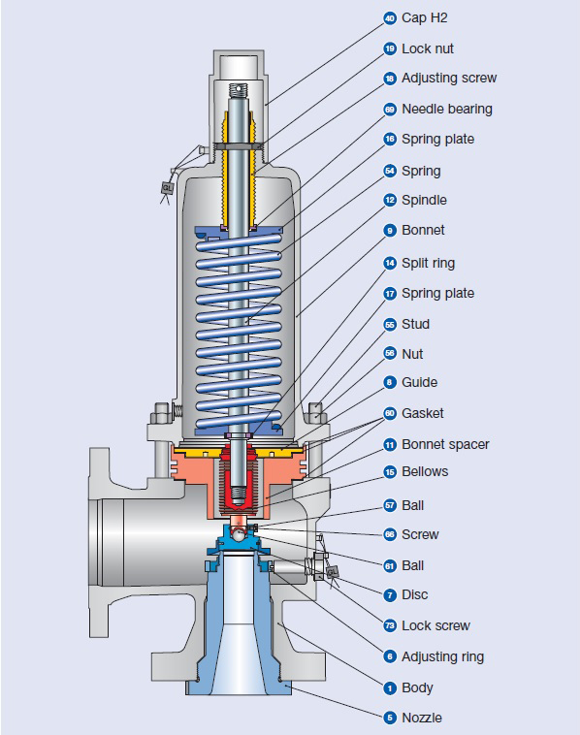

**6.PRESSURE RELIEF VALVE DIMENSIONAL CHARACTERISTICS**

Actual discharge area - the measured minimum net area which determines the flow through a valve.

Bore area - the minimum cross-sectional flow area of a nozzle

Bore diameter - the minimum diameter of a nozzle

Curtain area - the area of the cylindrical or conical discharge opening between the seating surfaces created by the lift of the disc above the seat

Developed lift - the actual travel of the disc from closed position to the position reached when the valve is at flow-rating pressure

Discharge area - see actual discharge area

Effective discharge area - a nominal or computed area of flow through a pressure relief valve, differing from the actual discharge area, for use in recognized flow formulas to determine the capacity of a pressure relief valve

inlet size - the nominal pipe size of the inlet of a pressure relief valve, unless otherwise designated lift - the actual travel of the disc away from closed position when a valve is relieving nozzle area, nozzle throat area - see bore area

Nozzle diameter - see bore diameter orifice area - see effective discharge area outlet size - the nominal pipe size of the outlet of a pressure relief valve, unless otherwise designated

Rated lift - the design lift at which a valve attains its rated relieving capacity seat angle - the angle between the axis of a valve and the seating surface. A flat-seated valve has a seat angle of 90 degrees.

Seat area - the area determined by the seat diameter

Seat diameter - the smallest diameter of contact between the fixed and moving portions of the pressure containing elements of a valve

**7.OPERATIONAL CHARACTERISTICS OF PRESSURE RELIEF DEVICES**

Back pressure - the static pressure existing at the outlet of a pressure relief device due to pressure in the discharge system

Blowdown - the difference between actual popping pressure of a pressure relief valve and actual reseating pressure expressed as a percentage of set pressure or in pressure units

Blowdown pressure - the value of decreasing inlet static pressure at which no further discharge is detected at the outlet of a pressure relief valve after the valve has been subjected to a pressure equal to or above the popping pressure

Breaking pressure - the value of inlet static pressure at which a breaking pin or shear pin device functions built-up

Back pressure - pressure existing at the outlet of a pressure relief device caused by the flow through that particular device into a discharge system

Burst pressure - the value of inlet static pressure at which a rupture disc device functions

Chatter - abnormal rapid reciprocating motion of the movable parts of a pressure relief valve in which the disc contacts the seat

Closing pressure - the value of decreasing inlet static pressure at which the valve disc reestablishes contact with the seat or at which lift becomes zero

Coefficient of discharge - the ratio of the measured relieving capacity to the theoretical relieving capacity

Cold differential test pressure - the inlet static pressure at which a pressure relief valve is adjusted to open on the test stand. This test pressure includes corrections for service conditions of superimposed back pressure and/or temperature.

**8.ADVANTAGES AND DISADVANTAGES OF PRESSURE RELIEF VALVES**

**Advantages**

* Smaller package on the larger pipe sizes.
* More options for control.
* Seals more tightly as the system pressure approaches but does not reach set pressure.
* Control pilot can be mounted remotely.
* Some designs allow for changes in orifice size within the main valve.
* can be used in engines

**Disadvantages**

* More complex, resulting in various fail-open failure modes.
* More expensive at smaller sizes (starts to even out as pipe size increases).
* Small parts in pilot valve are sensitive to contaminant particles.

**9. CODES, STANDARDS AND RECOMMENDED PRACTICES**

Many Codes and Standards are published throughout the world which address the design and application of pressure Relief Valves. The most widely used and recognized of these is the ASME Boiler and Pressure Vessel Code, commonly called the ASME Code.Most Codes and Standards are voluntary, which means that they are available for use by manufacturers and users and may be written into purchasing and construction specifications. The ASME Code is unique in the United States and Canada, having been adopted by the majority of state and provincial legislatures and mandated by law.

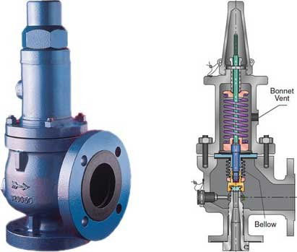

**BALANCED BELLOW VALVES**

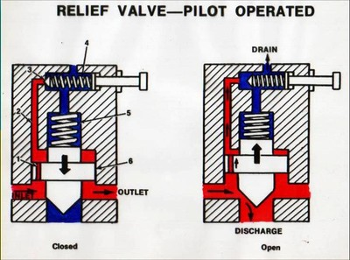

**RELIEF VALVE-PILOT OPERATED**

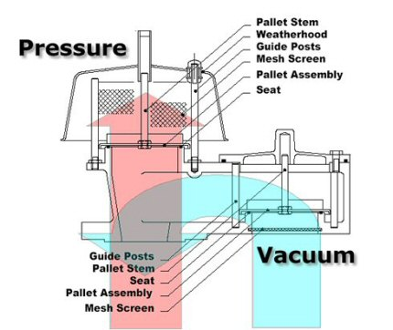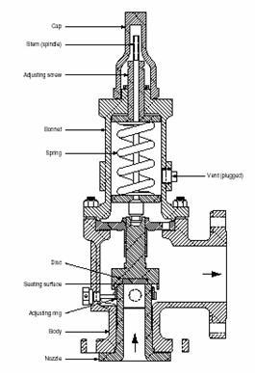

**VACCUM RELIEF VALVE CONVENTIONAL SAFETY**

**RELIEF VALVE**

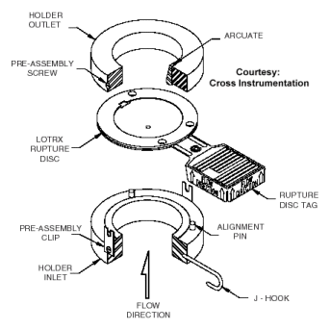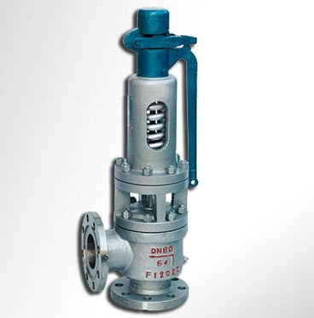

**RUPTURE DISC DEVICE SAFETY RELIEF VALVE**

**10.CONCLUSION**

The adequacy of any safety relief system is subject to certain conditions that are the principle basis for the design. Determination of correct required relieving capacity is often times the most obtuse step in the design process. For this reason, knowledge of sophisticated failure probability and evaluation techniques such as fault-tree analysis are important in making correct decisions regarding process upset severity. While the tired and true methods for pressure relief valve sizing are probably adequate, and generally produce conservative results, increased knowledge in the field of two phase hydraulics, highlighted by test work and information published by groups such as AIChE’s DIERS, should be considered in any design of a pressure relief system. Pressure relief valves should be designed to passively protect against a predetermined set of “worst case” conditions and should be installed to react to these conditions regardless of daily operation activities. For each piece of equipment requiring overpressure protection, a credible worst-case scenario should be defined. For a given vessel, several plausible scenarios may exist – from external fire to various operating contingencies, such as overfill or vessel swell conditions. System overpressure is assumed to be caused by the controlling scenario. Most controlling scenarios are loaded with conservative assumptions that are never achieved in actual operating conditions. It is the controlling scenario relieving rate that dictates the pressure relief valve size. If sized correctly, the pressure relief valve should have enough discharge capacity to prevent the pressure in the pressure vessel rising 10% above its maximum allowable working pressure.Thus we can conclude from this report that:

1. What are the safety devices?

2. Why are they used?

3. Where the used used?

4. Importance of safety devices.

Therefore, we can say that the use of process safety in plant life is veryimportant and if not used properly then they might adverse effects on the human life and the environment.

**11.REFERENCES**

1. Department of Labor, Occupational Safety and Health Administration, Process Safety Management of Highly Hazardous Chemicals, 29 CFR 1910.119, February 24, 1992.

2. American Society of Mechanical Engineers, ASME Boiler and Pressure Vessel Code, Section VIII, Pressure Vessels, Division 1, ASME, New York, 2001 plus addenda.

3. American Petroleum Institute, API Recommended Practice 520, Sizing, Selection, and Installation of Pressure-Relieving Devices in Refineries, Part I, Sizing and Selection, API, Washington D.C., 2000.

4. Fisher, H.G., et al., Emergency Relief System Design Using DIERS Technology, AIChE’s Design Institute for Emergency Relief Systems, DIERS, AIChE, New York, 1992.

5. Quoc-Khanh, Tran and Reynolds, Melissa, Sizing of Relief Valves for Two-Phase Flow in the Bayer Process, Kaiser Engineers PTY Limited, Perth, Western Australia, 2002.

6.http://webcache.googleusercontent.com/search?q=cache:http://kolmetz.com/pdf/EGD2/ENGINEERING_DESIGN_GUIDELINES_relief_valves_sizing_and_selection_rev_web.pdf&gws_rd=cr&ei=Htb6VoLqHsqOuAT3tIuoDw

7.http://www.pdhonline.org/courses/m112/Selection%20and%20Sizing%20of%20Pressure%20Relief%20Valves.pdf

8.https://en.wikipedia.org/wiki/Pilot-operated_relief_valve

9.https://www.google.co.in/search?q=pressure+relief+valve+images&rlz=1C1GIGM_enIN656IN657&espv=2&biw=1366&bih=667&tbm=isch&imgil=JQg56Ci4VOthsM%253A%253BgNNL-4lJkQPSYM%253Bhttp%25253A%25252F%25252

10.<http://www.cranefs.com/files/uploads/file/CPDs/Print_copy_CIBSE_safety_valves_approved_0911.pdf>